IDEATION PHASE

Brain Storming – Idea Generation

Project Title

Optimization of Users, Groups, Roles with Access Control and Workflows in ServiceNow

Objective

The objective of the brainstorming session was to identify common challenges in user and access management within organizations and generate ideas for improving security, efficiency, and automation using the ServiceNow platform.

Idea Generation

During the brainstorming process, several ideas were discussed regarding identity and access management. Organizations often face difficulties in managing users, groups, and roles manually, which can result in incorrect role assignments, duplicate user records, unauthorized access, delayed approvals, and security risks.

To overcome these challenges, the team proposed developing a centralized access management system in ServiceNow. The system focuses on automating user creation, organizing users into appropriate groups, assigning roles based on responsibilities, implementing Access Control Lists (ACLs), and automating approval workflows using Flow Designer.

Selected Idea

The selected project idea is Optimization of Users, Groups, Roles with Access Control and Workflows.

This solution provides:

- Centralized user management.
- Group-based access management.
- Role-based authorization.
- Secure access through ACLs.
- Automated approval workflows.
- Reduced manual effort.
- Improved security and compliance.

Expected Benefits

- Improved organizational security.
- Faster user provisioning.
- Reduced administrative workload.
- Better access control.
- Increased operational efficiency.
- Accurate audit and compliance management.

Conclusion

The brainstorming session concluded that implementing an optimized access management solution in ServiceNow would improve security, reduce manual work, and automate business processes through workflows and role-based access control.

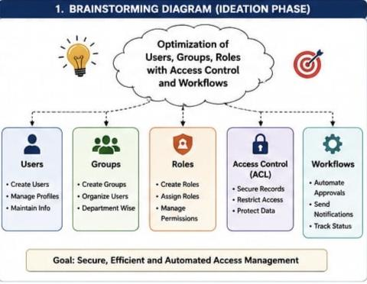

Define Problem Statements

Problem Statement

Organizations often face difficulties in managing users, groups, roles, and access permissions manually. As the number of employees and departments grows, manual administration becomes time-consuming, error-prone, and difficult to maintain.

Some common problems include:

- Manual creation and management of user accounts.
- Incorrect or duplicate role assignments.
- Unauthorized access to sensitive information.
- Delays in approval processes.
- Lack of centralized access management.
- Difficulty in tracking user permissions and activities.
- Increased administrative workload.
- Inconsistent security policies across departments.

These issues can lead to security risks, reduced productivity, and inefficient business operations.

Proposed Solution

To address these challenges, a ServiceNow-based solution is proposed that optimizes user, group, and role management by implementing secure Access Control Lists (ACLs) and automated workflows.

The proposed system provides:

- Centralized user management.
- Efficient group management.
- Role-based access control (RBAC).
- Secure access through ACLs.
- Automated approval workflows using Flow Designer.
- Reduced manual intervention.
- Improved security and compliance.

Objectives

- Optimize user and role management.
- Improve access security.
- Reduce manual administrative effort.
- Automate approval workflows.
- Ensure users have only the required permissions.
- Maintain accurate audit records.

Expected Outcome

The implemented solution will improve efficiency, strengthen security, simplify user administration, and ensure controlled access to organizational resources.

Empathy Map Canvas

User Persona

System Administrator / IT Administrator

Says

- Managing users manually takes too much time.
- Access permissions should be secure and accurate.
- User requests should be approved quickly.
- I need an easier way to manage roles and groups.

Thinks

- Manual role assignment increases security risks.
- Automation will improve efficiency.
- The organization needs better access control.
- User management should be centralized.

Does

- Creates and manages user accounts.
- Assigns users to groups.
- Grants and removes roles.
- Reviews access requests.
- Configures workflows and ACLs.
- Monitors user permissions.

Feels

- Frustrated by repetitive manual tasks.
- Concerned about unauthorized access.
- Responsible for maintaining system security.
- Satisfied when access management is automated and accurate.

Pains

- Duplicate user records.
- Incorrect role assignments.
- Delayed approval processes.
- Manual errors.
- Security vulnerabilities.

Gains

- Automated workflows.
- Better security.
- Accurate role assignments.
- Reduced administrative effort.
- Faster approval process.
- Improved productivity.
- Easy maintenance and auditing.

Conclusion

The empathy map highlights the needs and challenges of system administrators responsible for user and access management. The proposed ServiceNow solution addresses these pain points by providing automation, role-based access control, and secure workflows, resulting in improved efficiency and stronger organizational security.

